[Document title]

[Company name] | [Company address]

[Document subtitle]

Suraj Dangwal

[Year]

Table of Contents

1.Introduction 3

1.1Background 3

1.2Current situation 3

1.3 Our proposal & purpose 3

1.4 Scope 4

1.5 Measurable organisational Value 4

1.6 Aim/Objectives 4

1.6 Stakeholders: who will benefit it, impact? 5

2 Literature Review 7

2.1 Save The Power – The Flavare (2016) 7

2.2 Defenders of Nature - Games From YovoGames! 8

2.3 Nature Warrior – Akshay Jhadav(2018) 8

2.4 Save Water – Warmodroid (2015) 9

2.5 Protect the Tree – MoonBear LTD (2016) 9

2.6 Garden Games for Kids – Miniclub by Bubadu (2017) 10

2.7 Jungle Doctor – Libii (2014) 10

2.8 Save The World – King Abdullah II Fun for Development (2014) 11

2.9 Comparison Table 11

2.10 Discussion & Conclusion 12

2.11 Summary 13

3 Software Methodology: SDLC Spiral Model 14

3.1 Why Spiral model? 14

3.2 Spiral Model Diagram 15

3.3 How we will use this Model? 15

4 Game Design & Analysis 17

4.1 Game Menu 17

4.2PLAY GAME – LEVEL 1 18

4.3 Example 1 preview 19

4.4 Example 2 Preview 19

4.5 TOUCH INTERACTION FLOWCHART 20

4.6 PROGRESSING LEVEL FLOWCHART 21

4.7 Overview Flowchart 22

4.8 USE CASE 23

4.9 OVERALL NAVIGATION 23

5 Resources Collections 24

5.1 Software 24

5.1.1 Unity & Unity’s asset Store 24

5.1.2 Android Studio 24

5.1.3 Visual Studio 24

5.1.4 Unreal Engine’s asset store 25

5.1.5 Office 365 25

5.1.6 WhatsApp 25

5.1.7 Adobe Photoshop 25

5.1.8 Github 25

5.1.9 Stack overflow website 26

5.2 Hardware 26

5.2.1 Fast PC Desktop 26

5.2.2 Android Mobile Device 26

5.2.3 Flash-drive/USB storage device 26

6 Project Risks 27

6.1 Eight Weeks Deadline Time 27

6.2 Amateur Game developer 27

6.3 Time Management/Scheduling 27

6.4 Finding assets for the game 28

# 1.Introduction

Electricity is one of the key-resource of modern society. Almost everything what we do in our day to day life requires electricity. It plays a major role in household activities, school, colleges, industries and many more things. As we need electricity for most of our work, we tend to consume it more. There are situations when we consume electricity even if it is not required which leads to its wastage. Also, the consumption of electricity is very high, and it keeps increasing.

Most of the countries in the world use natural resources for producing the electricity. High consumption means we have to use more resources to produce electricity, which could lead us to a situation of high-power demand and its scarcity in future. Our project is to spread awareness about importance of saving the electricity all over the world. There are countries which use resources like oil and coal to produce electricity. The more amount of electric consumption leads to burning of more amount of coal and oil which is not only bad in terms of natural resource usage, but it is harming the environment as well.

The energy consumption can be reduced significantly if people learn to avoid wasting electricity unnecessarily. Though everyone from children to adults can be a part of the problem but we are focusing mainly on children because we believe that educating children is the best way to convey our message since an educated and responsible child will not only bring awareness within the family, but it will benefit the entire society.

## 1.2 Issue

Children at very young age are not aware about the importance of saving electricity. There are not many android games available on internet or on google play-store with similar learning experience that can help educate children on this concept.

## 1.3 Purpose

The opportunity arises for us to develop an educational game that will convey our message to children, since entertainment methods can be more effective and attractive way to motivate children.

## 1.4 Scope

It will enhance their decision-making skill as well. We have a scope of spreading awareness amongst the children between 4-6 years of age with the help of which they will learn and become more responsible towards saving the electricity. It will help in reducing the unnecessary consumption or wastage of electricity

## Aim & Objectives

Our aim is to design and develop an educational android game for children between 4-6 years of age that will teach them the concept of saving electricity.

Following are our objectives:

1. Easy navigation: The children should be able to navigate easily. This means our game interfaces will be simple to understand. The game menu will have 2 buttons, for playing and exiting the game.
2. Conduct research on similar games: This will help us in identifying the factors that are required to create an educational game and also identifying the areas where we can make improvements.
3. Audio & Visual implementations: The game will rely heavily on audio and visuals. We will make sure that we create scenarios with attractive visuals for children and also include audio in form of voice to help communicate with children which is more effective than texts.
4. Implement Simple Interface: Our game will not have too many interfaces to complicate things for children. We will implement a progression bar for determining how close a player is to complete the level. Another interface for 3 failed attempts which means after 3 failed attempts, the game will end and restart automatically.
5. Different levels: Different levels will be used to present different scenarios and challenges for children. The levels will somewhat reflect real life situations but in the form of a game.
6. Interactable objects: Throughout the game, children as a player will come across different interactable objects which will keep them engaged.
7. Reward system: We will implement a simple reward system that will motivate children to continue playing the game.

## 1.6 Measurable organisational Value

Our project will impact mainly on two areas:

1. Social & Environmental
2. Financial

Social & Environmental:

The game will bring awareness amongst children about power consumption. This means our game will encourage and influence children to make wise decision when using electricity. It will benefit the family, schools, governments and entire society.

Environment will be benefited due to reduction in usage of natural resources and it will also help in reducing the pollution caused by burning of oil and coal.

Financial:

Reduction in consumption of electricity will generate low cost bills, benefitting the family and businesses.

## 1.7 Stakeholders: who will benefit it, impact?

Our game will have an impact on 5 main stake holders, they are:

1. Children: Children will learn and become responsible. It will improve their decision-making skills.
2. Parents: Parents will be happy to see their child becoming responsible at very early age and also, their house will generate low electricity bill.
3. Electricity organisations: Electricity organisations will have to spend less on operational costs. It also means that they will make less money.
4. Schools: School will be benefitted by having responsible children.
5. Government: Government will have to spend less money and efforts to meet the power needs of the nation.

## 1.8 Research Question

Can our educational game influence/teach children the concept of saving electricity?

This question will help us to figure out whether our game will have the desired impact on children or not. Therefore, we will be focusing on implementing simple interfaces and also provide voice assistant to the children throughout the game. Our plan is to develop the game including specified objectives within the given timeframe and meet the research requirements.

# 2 Literature Review

## 2.1 Save The Power!

Save The power is an android game available on google play-store. This is an arcade game made for people of all age group. It has around 100+ downloads and a rating of 4.7 with just 23 reviews. This game is developed by “The Flavare” (Google Play Store 2015).

The objective of the game is to switch off the lights of empty rooms and to avoid switching off lights from occupied rooms.

The developer of this game has also provided a time limit of 3000 milli seconds within which if a player fails to click a correct room then the game will automatically end due to time constraint. The game consists of score board.

However, the game lacks several things. For instance, the time constraint meter runs very fast due to which player will find it very difficult to play and game will end very quickly. The game has only one scene and theme. The game doesn’t have different art style to keep children attracted and engaged. The developer has mentioned that the game is developed just for fun and there is no educational purpose. This game include text as well which is not suitable for children between 4-6 years of age.

## 2.2 Defenders of Nature - Games from YovoGames!

Defenders of Nature is an android game for children which helps them learn about the importance of nature and how to maintain cleanliness. The game consists of different levels. Each level provides different activities for children which will ultimately benefit the environment.

The game is developed by “yovogames” for children available on Google Play Store and it has 1000+ downloads with 4.5 average ratings from 84 users.

It educates children about which environmental waste should go in which rubbish bin for recycling purpose. The game also emphasises on educating the children about gardening activities i.e. removing the dead plants and planting new tress. Providing sufficient water to each tree and flower to help them grow. It also educates children about cleaning and saving water in a game level in which children have to remove rubbish from water and fix the leakage system.

However, the game has few drawbacks as follows:

It doesn’t have score board or reward system or any progressive bar to catch the attention of children in order to motivate them in playing the game.

Not enough animation feedback to help children if they get stuck.

## 2.3 Nature Warrior – Akshay Jhadav(2018)

Nature warrior is an android game which is developed to show the importance of maintaining the ecological balance by planting more and more trees around the city. Throughout the game, developer has provided different types of trees that a player will have to plant according to the climatic condition to balance the environment. The developer has also provided a range bar with the help of which player will figure out whether the tree that he/she is planting is proper or not as per the climate. If a player keeps planting a wrong tree, then the game will eventually end.

This game is available on google play store and has a rating of 3.5/5.0 given by 27 users and it has been downloaded 1000+ times.

Though the game is giving a good message and helping the player in educating them about the climatic threats we may face if we don’t have sufficient trees around us. But there are several issues with this game:

1)This game is not developed by keeping children in their mind since the speed of game is too fast which may be very difficult for the children.

2)The developer hasn’t provided animation support for the children about which trees should be used in which season.

3)Only 2 seasons provided in the game.

## 2.4 Save Water – Warmodroid (2015)

Save water is an android game available on Google Play Store developed by “Warmroid” for children. The game is very simple to play and the idea behind this game is to teach children the importance of saving water. In most countries people face the problem of water shortage due to improper water management system. Saving water during rainy season can be one of solution because the saved water can be reused.

In this game a player has to collect water droplets from sky and there is a count meter which shows the score i.e. the amount of water droplets saved in a bucket and the amount of water droplets missed/wasted.

The concept of the game is good, but it lacks several things in terms of gaining the attention of children:

It has only one theme.

No different levels and scenarios, as there are many ways in which water can be saved.

Water droplets in the game falls very quickly which will be difficult for the child to catch them in a bucket and eventually he/she may lose the interest from the game.

## 2.5 Protect the Tree – MoonBear LTD (2016)

Protect the Tree is an android game available in google app store. The idea of this game is to educate children about the importance of saving trees from people who cut them for their benefit which leads to deforestation. Trees are very important for every living being on earth. It helps controlling air pollution. Trees are major contributor in maintaining ecological balance.

The game is being downloaded more than 100k+ times and has an average rating of 3.8/5.0 given by 2k+ users.

In this game a kid as a player has to protect the last tree from group of enemies. In order to protect the tree, a player is being provided with options of several weapons which he/she can use to fight the enemies. There are several rounds in this game. With each round, enemies keep increasing and once the round is completed, a player is rewarded with coins. A player has to collect maximum number of coins to purchase more lethal weapons which are costly. Advance weapons plays vital role in killing enemies.

Protect the Trees is a good concept of educating the children about importance of saving trees, but this game has few drawbacks:

Due to improper landscape it is difficult for children to place the weapon in right areas for killing the enemies.

Theme of the game is very confusing.

## 2.6 Garden Games for Kids – Miniclub by Bubadu (2017)

Garden Games for Kids is a game based on a very nice concept of teaching children about how to nurture and save the plants. The plants in return provide us with healthy fruits, vegetables and flowers. It educates children to take proper care of plants by providing sufficient water to help them grow. It teaches children to keep harmful insects away from the plants and to remove dead leaves and dead parts which are of no use.

The game has good visuals for children to keep them interested while playing the game. It also helps children in form of an animation so that they don’t get stuck and confused while playing it. It educates children in placing the gardening tools at right storage areas.

This game is available on google play store and has received a rating of 4.3/5.0 from 8814 users and has been downloaded more than 1 Million times.

The only flaw this game has is that children may find it difficult to tilt the water pot and seed bag in order to sow the seeds and water the plants.

## 2.7 Jungle Doctor – Libii (2014)

Jungle Doctor is an android game developed for children to help the animals that are hurt or in need of immediate help. This game has very attractive visuals for children to keep them engaged in the game.

The game starts with showing a doctor travelling in a jeep to check the health of animals in the jungle to make sure that every animal is safe and out of trouble. The player as a doctor carries medicinal and other kits that he/she may require to treat different type of injuries. It provides animation help to the children in form of hint so that they can figure out the next step they have to take. It has an additional feature of taking photo with the animals or any part of the jungle. After saving each animal the player is rewarded with stars. Different animals are used to make the game more interactable for children.

The game is available on Google Play Store and has an overall rating 3.9/5.0 given by 5567 users and has been downloaded more than 1M times.

It has few negative ratings because most of the children find it little tough to use the treatment tools since animation help is not available for some steps. Healing process takes long time.

## 2.8 Save The World – King Abdullah II Fun for Development (2014)

Save The World is a very simple android game made for children which consists of three stages. In each stage a child as a player deal with different scenarios. When the game starts, first level consists of a dirty car and a player is provided with 3 options out of which he/she has to choose a correct option or else the game will end. It helps children in learning the concept of cleanliness.

In second stage of the game, developer intends to educate the player(child) about the harmfulness of industrial waste. A player has to select a correct option to save the water from getting contaminated. Thus, saving the water and aquatic lives.

In third stage,

The game has three simple stages with three different messages:

1)Cleanliness.

2)Save water and aquatic life from industrial waste.

3)Saving electricity.

To motivate the player, each stage has a reward once it is completed.

The game has a good rating of 4.8/5.0 given by 46 users and it has been downloaded 100+ times. This game is available on Google Play Store.

However, in third stage there is a target to switch of 100 lights and the screen moves too fast, in which a child might find it difficult to go with the pace of game.

## 2.9 Comparison Table

|  |  |  |  |  |  |  |  |  |
| --- | --- | --- | --- | --- | --- | --- | --- | --- |
| **App No.** | **1** | **2** | **3** | **4** | **5** | **6** | **7** | **8** |
| **Name** | **Save the Power** | **Defenders of Nature** | **Nature Warriors** | **Save Water** | **Protect the Tree** | **Garden Game for Kids** | **Jungle Doctor** | **Save the World** |
| **Developed By** | **The Flavare** | **Games from YovoGames!** | **Akshay Jhadav** | **Warmodroid** | **MoonBear LTD** | **Miniclub by Bubadu** | **Libii** | **King Abdullah** |
| **Target age group** | **All age group** | **6 - 12** | **N.A.** | **All age group** | **All age group** | **8 & under** | **N.A.** | **All age group** |
| **Rating (1.0 – 5.0)** | **4.7** | **4.5** | **3.5** | **5.0** | **3.8** | **4.3** | **3.9** | **4.8** |
| **Total Reviews** | **23** | **84** | **27** | **7** | **2163** | **8818** | **5567** | **46** |
| **Google play store** | **Yes** | **Yes** | **Yes** | **Yes** | **Yes** | **Yes** | **yes** | **Yes** |
| **Audio** | **Yes** | **Yes** | **Yes** | **Yes** | **Yes** | **Yes** | **Yes** | **Yes** |
| **Visuals** | **Yes** | **Yes** | **Yes** | **Yes** | **Yes** | **Yes** | **Yes** | **Yes** |
| **Reward system** | **No** | **No** | **No** | **No** | **Yes** | **Yes** | **Yes** | **Yes** |
| **Score board** | **Yes** | **No** | **Yes** | **yes** | **No** | **No** | **No** | **Yes** |
| **2D/3D Style** | **2D** | **2D** | **3D** | **2D** | **3D** | **2D** | **2D** | **2D** |
| **Multiple Levels** | **Yes** | **Yes** | **No** | **No** | **Yes** | **Yes** | **No** | **Yes** |
| **Animation help** | **No** | **Yes** | **No** | **No** | **No** | **Yes** | **Yes** | **No** |
| **Downloads** | **100+** | **1000+** | **1000+** | **1000+** | **100K+** | **1M+** | **1M+** | **1000+** |
| **References** |  |  |  |  |  |  |  |  |

## 2.10 Discussion & Conclusion

Apart from couple of educational games we could not find more games similar to our concept of saving electricity. Therefore, for comparison we have gone through other games as well which are not related to saving electricity, but they teach children to save something which is very important for human beings, animals and environment. We thought that we can implement some good ideas from each of the game which will benefit children, be it in terms of good themes and objects that we can include to make our game more interactable and attractive for children.

Out of all the games that we reviewed, Garden Game for Kids and Jungle Doctor are the two game that have been downloaded and reviewed by most people. Each of these games have been downloaded more than 1 million times.

Garden Game for Kids has received many good feedbacks from parents of the kids who played this game. It consists of good background theme and sound. It greets the children when the game begins. Have several interactable objects. With this game the developer intends to teach kids, how to nurture and take care of the plants which in return provides healthy fruits, plants and vegetables. Throughout the game developer has provided the animation support so that a player should not get stuck. This game also has the highest rating with 4.5/5.0 given by 8821 users. Jungle Doctor has many features that can attract the children. This game consists of several wild life animals shown in a cute way to keep the children engaged when the play. It has additional feature of taking snap while playing the game at any stage. It has reward system as well for the children in form of coins. It has received 3.9/5.0 rating from 5570 users. This game has animation support as well but in healing process there isn’t much of the animation help for a player and hence a child might get confused and stuck. Also, healing process takes long time. We believe that because of these two reasons “Jungle Doctor” have received a low rating compare to “Garden Game for Kids”.

Based on the inspiration from these two top level games, we decided to include some features in our game, such as animation support, greeting the children when the game begins, reward system in form of toys instead of coins, cute art style to make our game more appealing for kids.

We carefully reviewed all the games and found that except for few games, most of these educational games are made for people of all age groups whereas we are aiming to build an educational game for children between 4-6 years of age. Speed of most of these games are found to be too fast, hence a child might find it difficult to move along with pace of the game. Some games consisted of very few interactive objects and some games don’t even provide animation or any other type of support in their game. Apart from all these features, we thought that voice support is also one of the major factors in encouraging the children when they play a game.

Therefore, we concluded that, along with taking some features from the list of most famous games, we will also include voice support as well for the children to encourage them while playing. Voice support function is not available in detail in any of the educational game we reviewed. Also, we are intending to use no text in our game in order to simplify the experience for children and making it less confusing for them.

## 2.11 Summary

|  |  |  |
| --- | --- | --- |
| **Name** | **Pros** | **Cons** |
| **Save the Power** | 1. Simple Interface | 1. Game is too fast and not specifically designed for children between 4-6 years of age 2. Only one theme with no different level and scenarios 3. Less interactable objects 4. No reward system 5. It includes text |
| **Defenders of Nature** | 1. Different levels 2. Multiple activities for children 3. Good Visuals | 1. No reward system or appreciation for children 2. Not enough animation support for children |
| **Nature Warrior** | 1. Simple Interface | 1. Runs too fast 2. Minimal climatic effects 3. No different levels and scenarios |
| **Save Water** | 1. Have score system 2. Good theme and background | 1. Water droplets falls too quickly 2. No different scenarios or objects 3. No reward system |
| **Protect the Tree** | 1. Different objects used 2. Multiple rounds 3. Uses coins as rewards system. 4. Can purchase new weapons with accumulated coins | 1. Landscape is very confusing |
| **Garden Games for Kids** | 1. Good visuals 2. Good animation support for children 3. Multiple learning outcomes | 1. Difficult to tilt water pot and seed bag |
| **Jungle Doctor** | 1. Good visuals & themes 2. Different animals used to make the game more interactable for children 3. Can take picture in the game at any time | 1. Healing process takes long time 2. Not enough animation support for using treatment tools |
| **Save the World** | 1. Three different teaching outcomes in three different levels 2. Good reward system to motivate player | 1. Stage 3 runs too fast and not specifically designed for children between 4-6 years old 2. It includes text |

# 3 Software Methodology: SDLC Spiral Model

Spiral Model is a type of iterative development style with an emphasis on risk analysis. This Model has 4 phases and for game development it will follow these phases: <https://www.tutorialspoint.com/sdlc/sdlc_spiral_model.htm>

1. Design: In this phase we have to get all the requirements needed.
2. Implement: in this phase we will implement the design phase we decided.
3. Playtest: Then for playtest we can make sure and see if what we did works and is fun for the player.
4. Evaluation: we will evaluate what we done right and what we did wrong then we will try to improve it by going back to the design phase.

## 3.1 Why Spiral model?

Spiral model is very flexible especially when it comes to game development. We will need to implement many functionality into our game and playtesting will be a big factor and that is why we think spiral model is the best. Spiral model is also known to be commonly used in game development. Also because we have the incremental development style, we can add more things such as levels and additional features even when the game is released or published. This model also provides with other benefits such as quick prototyping, keeping risks low, and allowing changes quickly. <http://gamedevelopertips.com/spiral-model-for-game-development/>

## 3.2 Spiral Model Diagram

<http://gamedevelopertips.com/spiral-model-for-game-development/>

.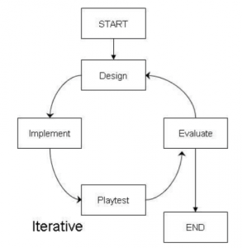

## 3.3 How we will use this Model?

Our first task is to make a basic design of main menu in the game, the main menu will have a Title of game, background Image, Logo or electricity based image, play button and exit button. The Main menu will be in portrait mode as well so after all that we need to implement all those design and then play test it. During play test we will check to see if our play button starts the first level as intended and if exit button closes the game app as intended. After the play test of the main menu we will then evaluate everything in that menu and see if we can make improvements to it, whether it’s better art style, image or maybe another button in the main menu.

The second task would be to design level one with all the objects we need. We will then implement the objects to be clickable or touchable and it should animate when touched/clicked on. We will then test out all the objects in the level, making sure that clicking all objects will play an animation (which is used to give feedback to the player that the object has been touched or clicked) and then lastly we will evaluate it. During evaluation we will check how we could make the animation better when clicking on objects and we could even add extra effects to our animations for a more appealing interaction with the object.

Third task will be to design and implement an icon on the top left corner to go back to the main menu. When we implement it the player should be taken back to the main menu of the game. We will test several times by going from main menu to in game and then from the in game level to the main menu by pressing the home menu icon on the top left corner of the screen. We will evaluate this implementation and see if we can make it better with help of animations or things like loading screen etc.

Fourth task will be to implement an audio voice at the start of the level, this audio will be used to communicate the objective of the level, for example when the level starts, there will be a voice explaining the scenario like “It is a bright and sunny day, mum and dad left for work and gave us the job to turn off all the electronics that are wasting power. Can you find what is wasting power?” and so a voice assistant like this will be used in the beginning of every level. After the implementation we test the game at least 3 times from menu to starting the game and check if the audio plays at the beginning of the level. After testing we will evaluate the audio, whether it is a good structured dialogue for kids with a nice friendly tone and if it needs an improvement we will implement it again with the improvements.

Fifth task is to design and implement a progress bar, the progress bar will be used when the player selects the correct object, and if it’s a correct object the progress bar will keep on filling till its maxed. We will then test it by selecting each object, correct objects should fill the bar a bit and incorrect objects should not affect the progress bar (we will use failure interface for the incorrect objects). After testing it 3 times at least we will then evaluate what we have so far and see where we can make improvements.

The sixth task will be to continue where we left off after the fifth task, we will now make sure that once our progress bar is full, the player should be shown a level complete screen and proceed to the next level. After designing and implementation, we will test these out by trying it at least 3 times and afterwards we will evaluate to see what we did right and what we did wrong. If we need improvements we will design and implement it again with the improvements.

Seventh task is it design and implement a simple UI for failed attempts which will be used to display a maximum of 3 crosses or X’s, if the player gets 3 X’s then the level should restart all over again. We will need to test this one out carefully as it might break the whole game, so we will test this one for at least times to see if everything is working as intended. When the player clicks an incorrect object, one X should be added to the top right corner, and if the player gets all 3 then restart the level. We will evaluate this as the last phase and see what we did right and where we could improve.

After implementing all the core functionalities mentioned from first task to seventh task, we can start designing and implementing different levels that have different scenario and challenges with the core functionalities already worked on. We can use the same functionalities from level 2 and implement in on to level 2 and other levels very easily since we have tested it all out one by one.

# 4 Game Design & Analysis

## 4.1 Game Menu



Since we are developing an educational game for children between age 4 to 6 years old, we thought that we should make our game menu simple but effective. Our game menu will have a title which is the only exception we will make because every game needs a title and we plan not to use any text in our game so children can’t be confused by several texts and some may not be able to read. The play and exit button will use an image instead and not a text based button. The menu will also contain a background music and art style to be more pleasing. The screen itself will be in portrait mode for the menu, we don’t think it would make much difference regardless of portrait mode or landscape mode since it is a main menu but we think that portrait mode will be a little bit more user friendly since people hold their phone as if they are using portrait mode.

## PLAY GAME – LEVEL 1



Our main functionalities will be used when the level starts. Every level will have its own art style, scenario and objects. Beginning of the level a voice assistant will be used to communicate the objective of the game and give feedback to the player whenever they touch an object. We have the main menu icon in the top left corner which will take the player back to main menu. The fail or attempt indicator on the top right corner will keep track of player’s incorrect choices, if player gets 3 strikes on the attempts then the level will start automatically and it will be shown in form of a cross or X as it is appropriate design for fails and attempts. The lower progress bar in the bottom center will indicate the progress of a player and every time they click the correct object, the progress bar will fill bit by bit until it is maxed out which will lead to level completion and advances the player to the next level.

Each level will also have a different art and object placement. All objects will be interact-able so when the player touches the object, the object should animate as a visual feedback to let player know that object has been touched. There will be correct objects and incorrect objects based on the level and the scenario the player is presented. We will also add some sparkle or shiny effect on top of the object to indicate that these objects are interact-able, what this does is makes children attracted to the shiny or sparkle effect which will get them to touch the object and then with the help of voice feedback they will automatically discover how to play the game and what they should be doing once they have experienced playing around with it. Lastly the levels will be locked in landscape mode which is the most appropriate for our game as we will need the space for the art style and objects placed in the level.

## 4.3 Example 1 preview

Caption the image

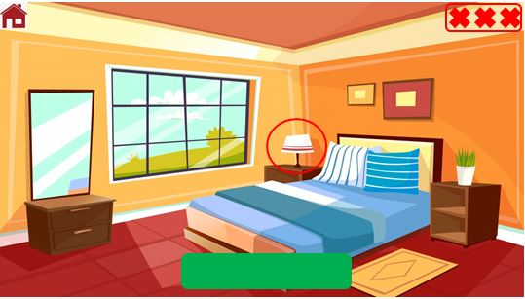

## 4.4 Example 2 Preview

Caption the image

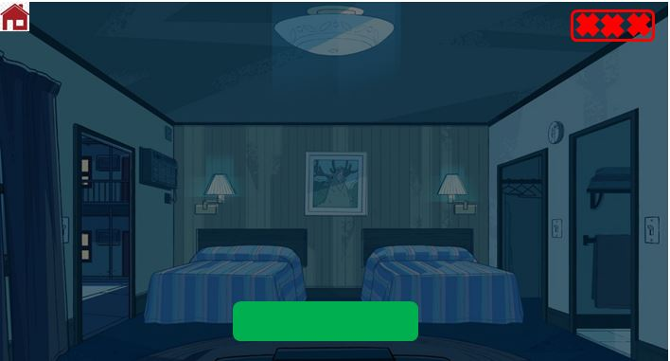

## 4.5 TOUCH INTERACTION FLOWCHART

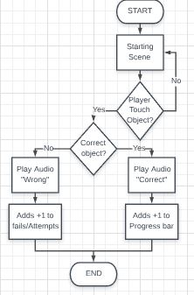

## 4.6 PROGRESSING LEVEL FLOWCHART

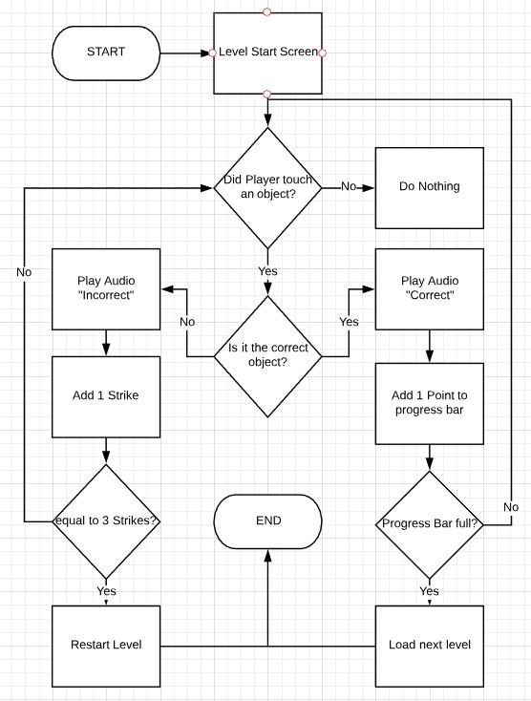

## 4.7 Overview Flowchart

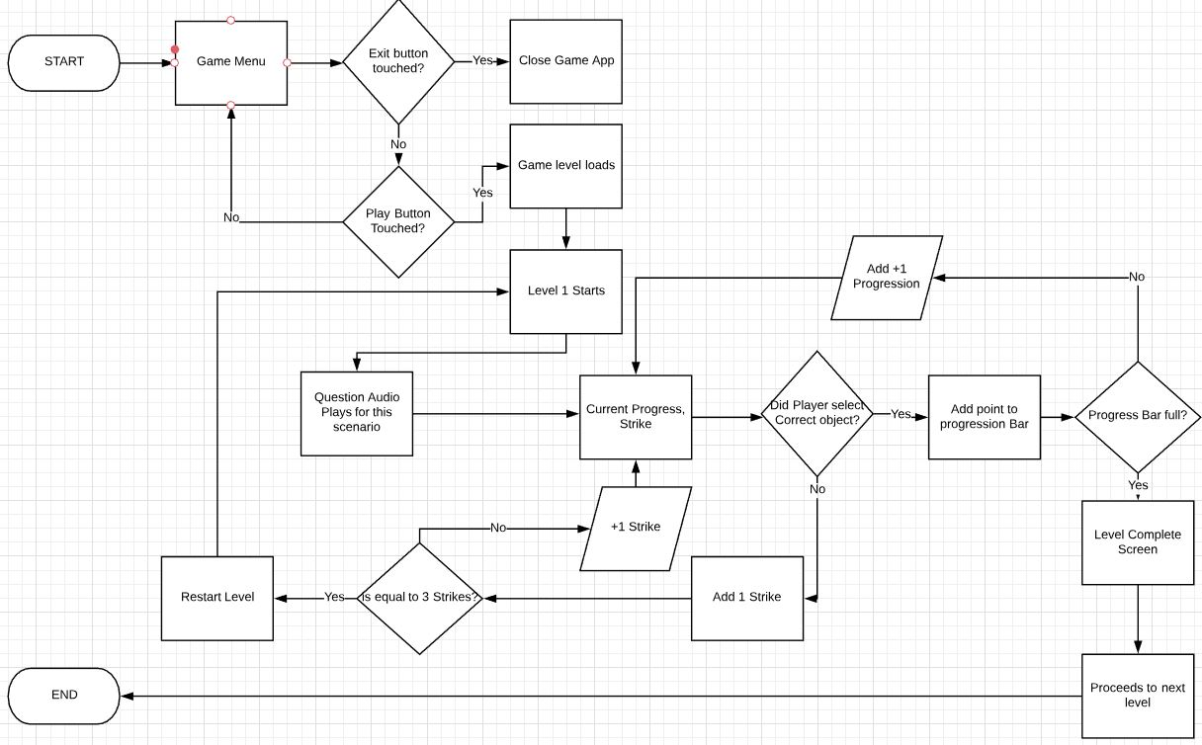

## 4.8 USE CASE

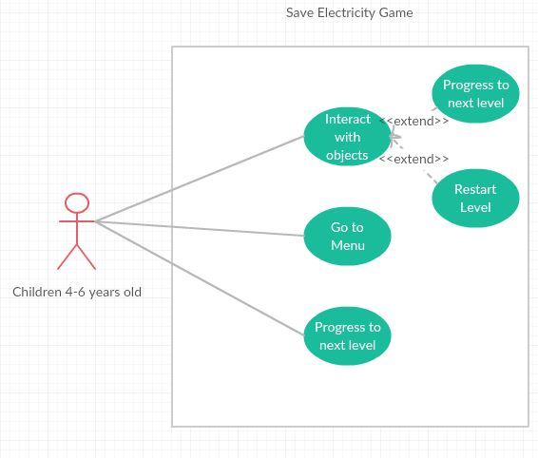

## 4.9 OVERALL NAVIGATION

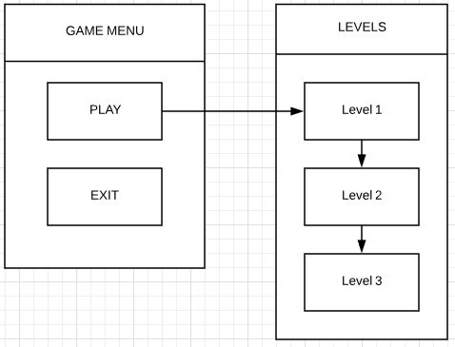

# 5 Resources Collections

## 5.1 Software

### 5.1.1 Unity & Unity’s asset Store

Unity is a free game developing software; It is very popular and contains a lot of resources and materials in itself for game developers such as artwork, animations, models, and many more things in the unity store. There are many free assets too and even the ones that are not free have somewhat a reasonable and cheap pricing.

We will be using Unity to develop our android game. The Unity game engine uses the c# programming language which I , Kunal Prakash as the developer am comfortable with and more used to. It will also help with obtaining assets that will be needed for our game development. There are also additional nice features with unity such as you are able to use visual studio with it when coding.

### 5.1.2 Android Studio

Android studio is software made for developing android apps and has additional useful tools such as android phone emulation. Although we won’t be using android studio for developing a game, it still might be useful for running the game on Android Studio’s emulation feature so that we can test the game out.

### 5.1.3 Visual Studio

<https://en.wikipedia.org/wiki/Microsoft_Visual_Studio>

Visual studio is also very popular IDE (Integrated development environment) for developers and can be used for many things such as web development, computer programs, web apps, web services and even mobile apps. We will mainly use visual studio for coding and its Intellisense feature that helps with coding.

### 5.1.4 Unreal Engine’s asset store

Unreal Engine is also similar popular game development software as Unity, It is the competitor of Unity and is also free. The reason for selecting Unreal engine eventhough we already have Unity as our game development software is because we can get assets from unreal’s asset store which will mean that we will have plenty of resources available for developing a game. So if theres something we are looking for such as artwork in the unity asset store and we cannot find it, we could always search the unreal asset store to see they have something we like.

### 5.1.5 Office 365

We will be using Microsoft software such as word, excel, powerpoint for things such as documentation, presentation and creating graphs. These software will be very important for us as we will be relying on it a lot and will be one of the most commonly used software throughout our project.

### 5.1.6 WhatsApp

WhatsApp is one of the many ways we communicate between each other. We also use whatsapp for sharing files together.

### 5.1.7 Adobe Photoshop

Photoshop is a popular software used for imaging and graphic design. <https://www.adobe.com/nz/products/photoshop.html> This can help us with designing our own art or combining multiple art together. It is a very handy tool and since we are building an android game, the art or visual will play a big role during our planning and design.

### 5.1.8 Github

Github is a very popular website for developers to share and work on a project together. The website will be used to upload our files, share files and update each other’s files whenever we can. This will provide us some flexibility in working together in a nicely organized manner.

### 5.1.9 Stack overflow website

Stack Overflow is a very handy and popular website for developers all around the world. You can answer or ask questions relating to development and coding. This will be very handy for us as we will require assistance from time to time if we come across any errors so this website will help us in finding solutions to our problems during development.

## 5.2 Hardware

### 5.2.1 Fast PC Desktop

We will be using the PC desktop to run all the software that will be required when developing the game. The desktop is fast enough to run everything efficiently and without a problem. Desktop is also used for communication and researching.

### 5.2.2 Android Mobile Device

A cheap android device will be used for testing purposes only. It will play a important role in testing when we try different functionalities and will help us debug problems/errors.

### 5.2.3 Flash-drive/USB storage device

We will need to backup different versions of our game development as we progress throughout the development. This will ensure we have working versions to fall back to if we come across any situation that might ruin or completely destroy our game file.

# 6 Project Risks

Our project will contain many risks and we will identify these risks and try to manage it in order to make sure everything goes smoothly and that our game’s quality is good.

## 6.1 Eight Weeks Deadline Time

We are given 8 weeks to complete our project. This can be very challenging task for us as there is some really time consuming factors that will be a factor in our project. Things such as testing, debugging and fixing errors will consume a lot of time. Same goes for researching; researching can also sometimes take a long time to find the relevant information or resources that will help us in our project.

## 6.2 Amateur Game developer

I (Kunal) am new to game development, this project being the second game I would need to work on and the first time developing a game specifically designed for android with 2D style. Many things such as unity software and unreal engine are relatively new to me. Overall game development is a learning experience as well so there will be many issues regarding the development. There is also a risk in implementing certain functionalities, due to lack of game development experience I will need to decide that I do not select a functionality that is too complex and out of my understanding or skillset.

## 6.3 Time Management/Scheduling

Both I (Kunal) and Suraj have different time schedules due to different lecture timings and availability. So, arranging meetings can be a little bit of a challenge for us. Suraj has a job that he has to go to so things like these can be risk and may delay our tasks that need to be completed.

## 6.4 Finding assets for the game

Our project will be heavily reliant on game assets, both during game development and also before game development starts. When it comes to mobile game development in the education category for kids, you won’t find many assets and examples that will help you develop an educational game for kids. Artwork, animations, characters and many more things will be needed to develop our game which should also be suitable for children so finding these assets can be a challenege and a risk if we are not able to get what we need.